**Certificate of Approval**

This is to certify that the project proposal entitled “**Student Record Management System**”

submitted by **[Your Full Name](Symbol Nnumber)**, **[Your Full Name] (Symbol Nnumber) and [Your Full Name] (Symbol Nnumber)** a student of Bachelor in Computer Application (BCA), **[Semester/Year]**, at **Gomendra Multiple College** has been approved as a bonafide work carried out in partial fulfillment of the requirements for the degree of Bachelor in Computer Application (BCA) under the affiliation of **[University Name].**

This proposal has been examined and evaluated and is found to be satisfactory in terms of scope, objectives, and methodology as per the academic standards set by the institution.

We hereby recommend this proposal for further development and implementation as a part of the final project work.





**Acknowledgement**

I would like to express my sincere gratitude to all those who supported and guided me in completing this project proposal titled “Student Record Management System”.

First and foremost, I would like to thank my respected teacher [Teacher’s Name] for their valuable guidance, encouragement, and constant support throughout the development of this project idea. Their suggestions and feedback were essential in shaping this proposal.

I am also thankful to my friends and classmates who provided helpful insights and motivation during this process.

Finally, I extend my heartfelt thanks to my family for their continuous support and understanding throughout my academic journey.

**Table of Contents**

Contents

Certificate of Approval i

Acknowledgement ii

Table of Contents iii

Introduction 1

Objectives 2

Problem Statement 3

Scope of the project 4

Methodology/Tools Used 5

System Requirements 7

Modules of the project 9

Flow chart 11

Algorithm 12

Expected Outcomes 14

Project Timeline 15

Conclusion 16

References 17

Another Topic 18

**Introduction**

In today’s digital era, educational institutions are increasingly moving toward computerized systems for managing their data and operations. One of the most essential aspects of any academic institution is maintaining accurate and accessible student records. Manual record-keeping methods are often time-consuming, error-prone, and inefficient, especially as the number of students grows.

The Student Record Management System is a console-based application developed in the C programming language that aims to simplify and automate the process of storing, retrieving, updating, and deleting student information. This system allows users to manage student data such as name, roll number, marks, and other essential details in a structured and secure manner.

The project focuses on applying the fundamental concepts of structured programming, including file handling, modular programming, and user-defined functions. By developing this system, students can gain practical experience in working with real-world problems using the C language, while also addressing the need for a more organized and efficient student data management solution.

This project will be especially helpful for small educational institutions or departments looking for a lightweight, offline system to manage student records effectively. The overall goal is to create a reliable and user-friendly system that reduces paperwork, saves time, and ensures data accuracy.

**Objectives**

The primary objective of this project is to design and implement a simple and efficient Student Record Management System using the C programming language. The system is intended to automate the process of managing student data in an educational institution. The specific objectives of the project are as follows:

1. To develop a console-based application that can store and manage student records efficiently.
2. To implement CRUD operations – allowing users to Create, Read, Update, and Delete student information.
3. To apply file handling in C for storing student data permanently in external files.
4. To ensure data accuracy and integrity, minimizing the chances of duplication or loss of records.
5. To practice modular programming, using user-defined functions for better structure, readability, and reusability of code.
6. To provide a user-friendly interface that can be easily used by non-technical users through simple menu-driven navigation.
7. To reduce manual work and paperwork by providing a digital alternative for managing student records.

**Problem Statement**

In educational institutions, maintaining accurate and up-to-date records of students is essential for smooth administrative and academic operations. Traditionally, many schools and colleges rely on manual methods such as paper-based files or Excel sheets to manage student data. These methods, while simple, come with significant drawbacks.

Manual systems are prone to errors in data entry, duplication of records, and difficulty in updating or retrieving specific information. As the number of students increases, organizing and managing records becomes more time-consuming and inefficient. Searching for a student’s details may require going through multiple files, and updating or deleting a record may lead to inconsistencies or data loss if not handled carefully.

Furthermore, there is a lack of data validation, which increases the risk of inaccurate information being stored. Generating reports, sorting records, or calculating average marks requires additional effort and often results in delays and reduced productivity.

The need for a computerized system that can perform these tasks accurately and efficiently is evident. A simple, console-based application developed in the C programming language can serve as an ideal solution. It can provide features like adding, viewing, searching, updating, and deleting student records, all while storing the data securely using file handling.

The Student Record Management System aims to address these problems by offering an automated solution that improves accuracy, saves time, and simplifies the process of managing student information for small-scale institutions or departmental use.

**Scope of the project**

The **Student Record Management System** is a console-based application developed using the C programming language that aims to simplify the management of student data in small educational institutions, departments, or training centers. The system is designed to help users perform essential data operations such as adding new student records, viewing all stored records, searching for specific entries, updating existing information, and deleting records when necessary.

This project focuses on implementing a **single-user, offline system** that stores data persistently using file handling, eliminating the need for external databases or complex software environments. It is particularly useful for academic departments or administrative staff looking for a lightweight and reliable solution to manage student information efficiently.

Key features included within the scope of this project are:

* **Data Storage:** The system will store student information (e.g., name, roll number, marks, etc.) in a structured format using text files.
* **CRUD Operations:** Users will be able to Create, Read, Update, and Delete student records through a simple and intuitive interface.
* **Search Functionality:** The system will allow for quick retrieval of specific student records using roll numbers or names as search criteria.
* **Data Display:** Users will be able to view all existing records in a well-organized format.
* **Error Handling:** Basic error checking will be implemented to ensure that invalid entries or duplicate roll numbers are managed properly.
* **File Handling:** The use of file I/O in C will provide persistent data storage even after the program is closed.

While the system will not include advanced features such as a graphical user interface (GUI), online access, multi-user support, or integration with a central database, it serves as a foundational tool for learning and practicing real-world application development in C.

The project is intended for educational purposes and is best suited for small-scale environments where simplicity, accuracy, and speed of access to student data are a priority.

**Methodology/Tools Used**

The development of the **Student Record Management System** follows a structured programming approach using the **C programming language**. The project is designed to be a console-based application, suitable for beginners and ideal for practicing core programming concepts. Below is a breakdown of the methodology and tools used in the project:

**1. Programming Language**

* The system is developed using **C**, which is well-suited for building low-level, efficient programs.
* Key concepts used:
  + **Structured programming**: breaking the program into smaller, manageable functions
  + **File handling**: to store and retrieve student records permanently
  + **Control structures**: loops, conditionals, switch-case, etc.
  + **Arrays and structures**: to handle multiple student records logically

**2. Design Methodology**

* **Modular Design**: The project is divided into logical modules such as:
  + Add student record
  + Display all records
  + Search a record
  + Modify a record
  + Delete a record
* This approach increases code reusability and makes debugging easier.

**3. Development Tools**

* **Code Editor / IDE**:
  + **Code::Blocks**, **Dev-C++**, or **Turbo C** can be used to write and compile the C code.
* **Compiler**:
  + **GCC (GNU Compiler Collection)** or the built-in compiler provided by the IDE
* **Operating System**:
  + Compatible with **Windows**, **Linux**, or **macOS**, depending on the compiler used.

**4. Data Storage Method**

* **Text file (.txt)** is used for storing student records.
* File operations include:
  + fopen(), fclose()
  + fprintf(), fscanf()
  + fread(), fwrite() for binary file operations (optional)

**5. User Interface**

* A **menu-driven console interface** is implemented to interact with the user.
* Options are presented through numbered menus for ease of use.

**System Requirements**

The **Student Record Management System** is designed to run efficiently on standard computer systems with minimal hardware and software prerequisites. Below are the detailed system requirements categorized into hardware and software components:

**1. Hardware Requirements**

* **Processor:**  
  A basic Intel or AMD processor with a minimum speed of 1 GHz or higher. Since the application is console-based and lightweight, it does not require a high-performance processor.
* **RAM(Memory):**  
  At least 512 MB of RAM is sufficient to run the program smoothly. The project is not memory-intensive.
* **Storage:**  
  The project requires minimal disk space (a few megabytes) mainly for the text files used to store student records.
* **Input/Output-Devices:**  
  Standard keyboard and monitor for user input and output display.

**2. Software Requirements**

* **Operating-System:**  
  The program can run on any modern operating system that supports a C compiler, such as:
  + Windows (7, 8, 10, 11)
  + Linux distributions (Ubuntu, Fedora, etc.)
  + macOS
* **Compiler and Development Environment:**  
  A C compiler and editor are required to write, compile, and run the code. Popular options include:
  + **Code::Blocks IDE** (includes GCC compiler)
  + **Dev-C++**
  + **Turbo C/C++**
  + Command-line GCC compiler on Linux/macOS
* **File System Access:**  
  The program requires permission to read and write files in the local directory for storing student records.

**3. Additional Requirements**

* **Console or Terminal Access:**  
  Since this is a console-based application, users must have access to a terminal or command prompt window to interact with the program.
* **User Permissions:**  
  The user should have adequate permissions to create, modify, and delete files.

**Modules of the project**

The **Student Record Management System** is divided into several functional modules to organize the code logically and to simplify implementation and maintenance. Each module focuses on a specific functionality within the system:

**1. Add Student Module**

* This module allows the user to **enter new student details** such as:
  + Roll number
  + Name
  + Age
  + Marks or grades
  + Department or class
* The entered data is then **saved to a file** for permanent storage.
* It performs **validation checks** to avoid duplicate roll numbers and incorrect inputs.

**2. Display Student Records Module**

* This module retrieves and **displays all stored student records** from the file.
* It shows the records in a **tabular or list format** for easy reading.
* Helps users to view the current database of student information quickly.

**3. Search Student Module**

* Enables searching for a particular student’s record using key attributes like:
  + Roll number
  + Name
* The system displays the full details of the searched student if found.
* If the student is not present in the record, it shows an appropriate message.

**4. Modify Student Record Module**

* This module allows the user to **update existing student information**.
* The user can search for a student by roll number and modify details such as name, marks, or other attributes.
* Changes are saved back to the file, replacing the old data.

**5. Delete Student Record Module**

* Enables the user to **delete a student record** permanently from the database.
* The user selects a student record by roll number for deletion.
* The record is removed from the file, and the updated data is saved.

**6. Exit Module**

* Provides a way to **safely exit the program**.
* Before exit, the program can prompt the user for confirmation to avoid accidental closure.

**Flow chart**

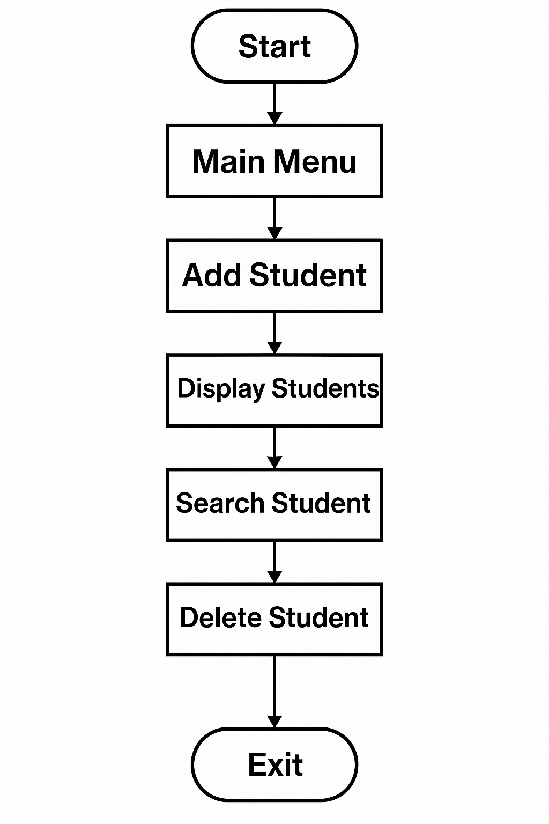

**Algorithm**

**Step 1:** **Start**

**Step 2:Initialize** an empty list or database to store student records.

**Step 3:Display menu options:**

* 1. Add student record
  2. View all student records
  3. Search student record
  4. Update student record
  5. Delete student record
  6. Exit

**Step 4:Input** user choice.

**Step 5:If** choice = 1 (Add student record)

* Input student details (ID, Name, Age, Class, etc.)
* Add the record to the list/database
* Display confirmation message

**Step 6:Else if** choice = 2 (View all records)

* Display all student records

**Step 7:Else if** choice = 3 (Search student record)

* Input student ID or Name to search
* Search the list/database
* If found, display student details
* Else, display “Record not found”

**Step 8:Else if** choice = 4 (Update student record)

* Input student ID to update
* Search for the student record
* If found, input new details
* Update the record
* Display confirmation message
* Else, display “Record not found”

**Step 9:Else if** choice = 5 (Delete student record)

* Input student ID to delete
* Search for the student record
* If found, delete the record
* Display confirmation message
* Else, display “Record not found”

**Step 10:Else if** choice = 6 (Exit)

* Stop the program

**Step 11:Else**

* Display “Invalid choice”

**Step 12:**Go back to step 3 (Repeat menu)

**Step 13:End**

**Expected Outcomes**

1. **Adding Student Records**
   * The system successfully accepts and stores complete student information such as ID, Name, Age, Class, and other relevant details.
   * Confirmation is displayed after each successful addition.
2. **Viewing All Student Records**
   * The system displays a clear, organized list of all stored student records.
   * Handles the case when no records exist by showing an appropriate message.
3. **Searching Student Records**
   * The system can accurately search student records by either student ID or name.
   * When a matching record is found, all relevant details are displayed clearly.
   * If no record matches the search criteria, the system informs the user with a “Record not found” message.
4. **Updating Student Records**
   * The system allows modification of any student information based on a valid student ID.
   * Displays confirmation after successfully updating the record.
   * Handles invalid ID input by notifying the user if the record does not exist.
5. **Deleting Student Records**

* The system can remove a student record when provided with a valid student ID.
* After deletion, a confirmation message is shown.
* If the ID is invalid or not found, the system displays an error message.

1. **Handling Invalid Inputs**
   * The system prompts the user when an invalid menu option or incorrect input is entered.
   * Ensures robustness by preventing crashes or data corruption from invalid inputs.
2. **System Exit**
   * The system terminates cleanly upon user request.
   * Before exit, any necessary data saving or cleanup is performed (if applicable).

**Project Timeline**

| Phase | Duration |
| --- | --- |
| Requirement Analysis | 1 Week |
| Design (Flowcharts/Plan) | 1 Week |
| Coding & Development | 2 Weeks |
| Testing & Debugging | 1 Week |
| Documentation | 1 Week |
| Final Submission | As Scheduled |

**Conclusion**

The **Student Record Management System** is a valuable and practical solution designed to address the basic yet essential need of managing student data in a structured and efficient way. This project demonstrates how fundamental programming concepts can be applied to solve real-life problems, particularly in educational institutions that still rely on manual record-keeping processes.

By developing this system in the **C programming language**, the project emphasizes the use of core programming techniques such as structured programming, file handling, conditional logic, looping, and user-defined functions. Through this, it provides the developer with hands-on experience in building a functional application that performs data storage, retrieval, modification, and deletion—all crucial for managing records accurately.

The system helps reduce errors, improves accessibility, and saves time compared to traditional manual systems. Users can easily search for records, make updates, or remove outdated data without flipping through piles of documents. It ensures that data is stored permanently using files, making it reusable across multiple sessions without requiring a database system.

Although the project is limited in scope—being a console-based and single-user application—it lays a strong foundation for further development. In the future, the system could be extended to include a graphical user interface (GUI), database integration, multi-user support, and web-based access for broader usability.

Overall, the **Student Record Management System** successfully meets its objectives and proves to be an effective tool for small-scale student data management, while also enhancing the programmer’s technical skills and confidence in developing real-world applications using the C language.

**References**

1. **Kanetkar, Yashavant.** *Let Us C* (17th Edition) – BPB Publications
2. This book was an essential reference throughout the development of this project. It provided clear explanations of C programming concepts such as functions, arrays, structures, and file handling, which were directly applied in building this system.
3. **E. Balagurusamy.** *Programming in ANSI C*
4. Another highly useful resource for understanding structured programming techniques, modular design, and standard coding practices in C.
5. **GeeksforGeeks** – [www.geeksforgeeks.org](https://www.geeksforgeeks.org)
6. A comprehensive programming tutorial website that was used to clarify specific topics such as file operations in C, sorting algorithms, and string manipulation.
7. **TutorialsPoint** – [www.tutorialspoint.com](https://www.tutorialspoint.com)
8. Used to review concepts like functions, control structures, and data structures in C. It also helped in testing small code snippets during the development process.
9. **Class Notes and Lecturer Guidance**
10. Notes provided during the BCA course and discussions with subject teachers played a key role in understanding the requirements and planning the structure of the system.
11. **YouTube Programming Channels** (e.g., CodeWithHarry, ProgrammingKnowledge)
12. These channels provided visual explanations and sample code implementations, especially helpful during debugging and understanding real-time behavior of the application.
13. **Official C Programming Documentation** – https://en.cppreference.com/w/c
14. Used as a reference for syntax and standard C functions related to file I/O, pointers, and error handling.